Hollinswood Primary School and Nursery Pupil Premium Strategy Statement 2022 - 2023 Review

At Hollinswood Primary School we:

- Promote an ethos of attainment for all pupils, rather than stereotyping disadvantaged pupils as a group with less potential to succeed.

- Have an individualised approach to addressing barriers to learning and emotional support, at an early stage, rather than providing access to generic support and focusing on pupils nearing their end-of-key-stage assessments.

- Focus on high quality teaching first rather than on bolt-on strategies and activities outside school hours.

- Focus on outcomes for individual pupils rather than on providing strategies.

- Deploy the best staff to support disadvantaged pupils; develop skills and roles of teachers and TAs rather than using additional staff who do not know the pupils well.

- Make decisions based on data and respond to evidence, using frequent, rather than one-off assessment and decision points.

- Have clear, responsive leadership: setting ever higher aspirations and devolving responsibility for raising attainment to all staff, rather than accepting low aspirations and variable performance.
Barriers to learning for PPG pupils:

In-school barriers (issues to be addressed in school, such as poor oral language skills, vocabulary etc.)
- Gaps in learning post C-19 lockdown, especially for those pupils who had limited access to resources.
- Poor oral language skills and limited vocabulary on entry to school.
- Coupled vulnerability with SEND, behaviour and mental health needs is an issue for several our PP eligible pupils.
External barriers (issues which also require action outside school, such as low attendance rates)
- Ensuring that our Disadvantaged pupils frequently attend school is also an aspect may prove to be an external barrier

Intended outcome | Success criteria | Activity | Impact
Improved oral language skills and vocabulary among disadvantaged pupils. | Assessments and observations indicate significantly improved oral language among disadvantaged pupils. This is evident when triangulated with other sources of evidence, including engagement in lessons, book scrutiny and ongoing formative assessment. | Embedding dialogic activities across the school curriculum within EYFS and Year 1 such as:  - targeted reading aloud and book discussion.  - explicitly extending pupils’ spoken vocabulary.  - the use of structured questioning to develop reading comprehension; and  - the use of purposeful, curriculum-focused, dialogue and interaction.  - Identifying key vocabulary at the planning stage and share with all practitioners. Practitioners to model the use of vocabulary in the correct context.  - The use of oracy strategies to improve verbal reasoning and expression. | All subject leaders have identified key vocabulary on progression maps and these are referred to in every lesson, which has had a positive impact on children’s knowledge of tier 3 vocabulary. This year, the focus will be developing children's use and knowledge of tier 2 vocabulary, using explicit vocabulary lessons during reading lesson time.  Pupil voice indicated that the greater understanding of a tier 2 vocabulary amongst PPG children is a strength, however, this recognition and understanding of a wider range of vocabulary is not yet evident in written work. 2023/24 Lead staff training on developing the use active vocabulary in the classroom.  Through development of oral language skills and continued explicit vocabulary instruction, the transfer of vocabulary knowledge and understanding will complete the transition from Stage 3 “Having context-bound and vague knowledge of the word's meaning” to stage 4, “Knowing the word well and remembering it and applying that word in an independent written context.”
Improved reading and writing data for disadvantaged pupils in Year 1. | Phonic outcomes in 2022 show that there is an increase in the % of disadvantaged pupils meeting the expected standard in phonics. (Current baseline 2/16)  Reading and writing outcomes in 2022 show that % of pupils achieving expected standard is in line with their peers. | Purchase of a DFE validated systematic synthetic phonics programme to secure stronger phonics for pupils.  Purchase reading materials that follow the systematic phonics programme.  Purchase of Phonics Tracker which provides diagnostic assessment information which can be used to identify barriers to learning. | Summer 2023 Y1 Reading  Non PPG 100% (34)  PPG 59% (7/12)  PPG + SEND 0% (0/3)  PPG + Girls 50% (3/6)  PPG + Boys 57% (4/6)  PPG + EAL 100% (5/5)  In Autumn 2022 33% of PPG children in Year 1 were on track to achieve expected standard in reading. Through implementation of  A systematic synthetic phonics programme, appointing a Reading Lead and joining the English Hub, at the end of Year 1 42% of PPG children were on target to meet end of year expectations and 17% were working above end of year expectations, which shows a positive impact on progress.  Summer 2023 Phonics data  Non PPG 89% (30/34)  PPG 67% (8/12)  67% of PPG children passed the Phonics Screening Check compared to 39% in 2021/22 which demonstrates a positive impact on progress.  PPG will continue to be a target group in phonics for 2023/24  Summer 2023 Y1 Writing  Non PPG 71% (24/34)  PPG 50% (6/12)  PPG + SEND 0% (0/3)  PPG + Girls 50% (3/6)  PPG + Boys 50% (3/6)  PPG + EAL 80% (4/5)  42% of PPG children were on track to achieve age related expectations in Summer 2023 and 8% were working above age related expectations, compared to 33% and 0% in Autumn 2022.  The development of vocabulary and sentence structure skills continues to be a focus for 2023/24.
Improved writing data for disadvantaged pupils in Year 3. | Year 3 writing outcomes in 2022 show an increase of the % of disadvantaged pupils achieving expected standard. Pupils will achieve in line with their peers. | Small group writing intervention with a focus on talk for writing and providing pupils with additional opportunities to practise sentence construction. This will we particularly targeted at disadvantaged pupils. | Y3 Writing Autumn 2022 Summer 2023  Non PPG 72% (30) 84% (36)  PPG 67% (10) 71% (10)  PPG + SEND 0% 0%  PPG + Girls 67% 84%  PPG + Boys 76% 63%  PPG + EAL 33% 50%  PPG girls and PPG EAL excelled with intervention, however PPG boys is showing a dip in attainment. This is due to external factors including: A looked after child returning to family; a child who is post-adoption and suffering from trauma related behaviour and a child whose family were rendered homeless which affected his attendance.  One child has now left to a school near to his new home. There is a behaviours plan in place for one pupil and we are seeking post adoption therapy services and there is additional support in class (short term) for pupils two and three. Also both pupils two and three are receiving support from the Inclusion leader.
Improved writing data for disadvantaged pupils in Year 5. | Year 5 writing outcomes in 2022 show an increase of the % of disadvantaged pupils achieving expected standard. Pupils will achieve in line with their peers. | Small group writing intervention with a focus on talk for writing and providing pupils with additional opportunities to practise sentence construction. This will we particularly targeted at disadvantaged pupils. | Y5 Writing Autumn 2022 Summer 2023  Non PPG 100% 90%  PPG 70% 77%  PPG + SEND 0% 15%  PPG + Girls 93% 100%  PPG + Boys 40% 38%  PPG + EAL 67% 100%  PPG girls and EAL excelled. There is a dip in attainment for PPG boys. It has to be noted that 2/4 PPG boys are also identified as SEN. One of these boys has a high level behaviour plan and risk assessment in place. A BeeU referral has been made and escalated. One other pupil, due to a number of family circumstances has had a dip in attainment. This child has had a settled start to Year 6 which will be monitored as the term progresses.
To achieve and sustain improved well-being for all our pupils in school, particularly our disadvantaged pupils. | Sustained high levels of well-being from 2021/2022 demonstrated by pupil voice outcomes and teacher observations.  An improvement in the quality of writing produced as result of increased resilience and stamina. | Improve the quality of social and emotional (SEL) learning.  SEL approaches will be embedded into routine educational practices and supported by professional development and training for staff.  DHT to attend Mental Health Lead training. Complete audit and devise action plan.  Provide training to all staff.  Evaluate impact.  Engagement with Arthog Outreach to plan and deliver an enrichment activity programme with a focus on developing pupils’ well-being and resilience.  Targeted intervention led by Forest School Lead with a focus on problem-solving and teamwork.  Development of an implementation of art and drama extra-curricular activity with a focus on improving pupils’ well-being. | 10 children in Year 5 and 6 4 1hr sessions. Groups of 5 children in each session.  Aims:  - Build resilience  - Develop and strengthen friendships  - Increase physical activity outdoors for health benefits  Impact  - Children built resilience, perseverance and self-belief which has led to increased participation in lessons that they may at first perceive as difficult.  - Children were given opportunities to support each other which has developed and strengthened friendships. This has led to less child-on-child behaviour incidents in school.  - Children developed their independence and confidence which has transferred back into school when working, problem solving or playing with friends.  Inclusion Leads have received training in mental health. One Inclusion Lead received training to deliver Drawing and Talking interventions and another Inclusion Lead received training to be a Mental Health Lead. Children whose families were receiving Early Help were identified to receive targeted sessions with Inclusion Leads, where we saw an impact in their abilities to regulate their emotions and engage with lessons more successfully. We recognise that this is a journey for these children and they will continue to receive targeted support next year.  Arthog outreach to continue in 2023/24 for a new group of identified pupils.  Trauma Based training will be delivered to all staff in 2023/2024. Drawing and Talking interventions will start following the training that took place in the Summer Term.
To achieve and sustain improved attendance for all pupils, particularly our disadvantaged pupils. | Sustained high attendance from 2021/2022 demonstrated by:  - the attendance gap between disadvantaged pupils and their non-disadvantaged peers being reduced.  - the percentage of pupils who are persistently absent is reduced for all pupils, particularly disadvantaged pupils. | Embedding principles of good practice set out in the DfE’s Improving School Attendance advice.  This will involve training and release time for staff to develop and implement new procedures and appointing attendance/support officers to improve attendance. | 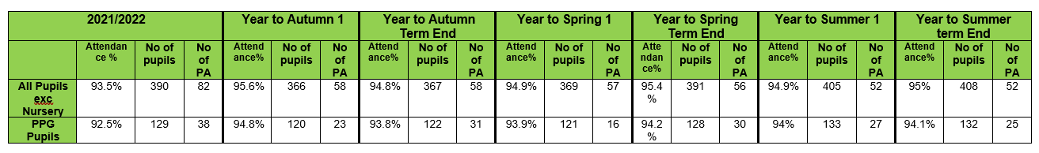  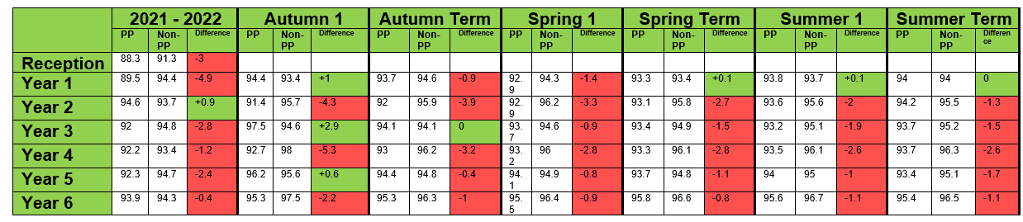  The percentage of pupils who are persistently absent has significantly reduced compared to 2021 – 2022 (38 compared to 25).  Th attendance gap between PP and non PP children has closed in some year groups, particularly Years 1, 2, 4 and 6.  Pupil Premium attendance remains to be a focus in 2023/ 2024, especially in years 3 and 5.

