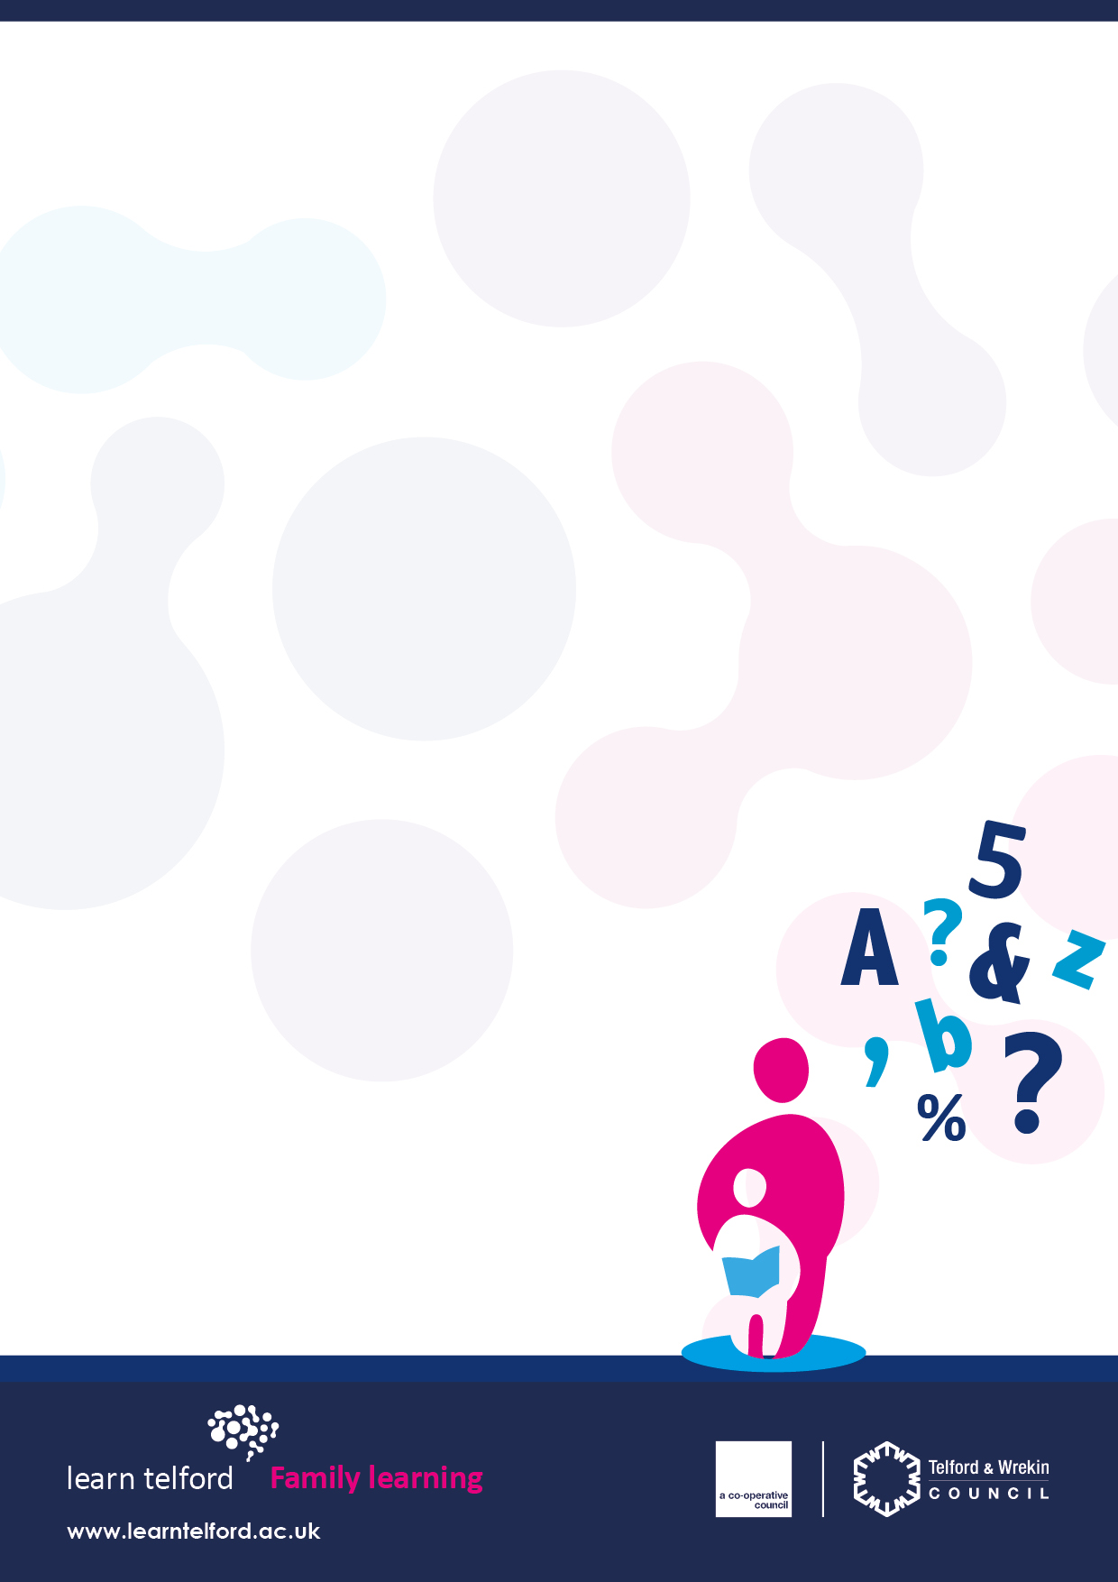

Hollinswood Primary

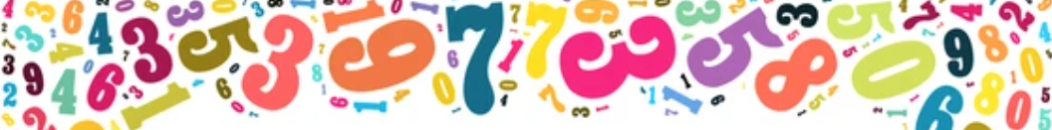



Thursday 15th September – 20th October 2022

9:00 – 11:00

**9:30 – 11:30 am**

* Enjoy crafts, making games and creative play to help your child with learning Maths and Numbers
* Understand how children learn through number games
* Learn practical strategies, ideas and craft activities to help

develop children’s learning though play at home

* Fun and relaxed sessions for you and your child

to be creative together

* Experienced tutor

Free Crèche subject to demand

You will need to register online to join this course;

<http://www.learntelford.ac.uk/PublicSites/CreateFromCourse/7932382>

For any support with Registering;

* 01952 382888
* support@learntelford.ac.uk



Fun and Crafty Numbers

Please return your slip to your School Administrator to book your place on the **Fun and Crafty Numbers course** at **Hollinswood Primary School** on Thursday 15th September – 20th October, 9:00 – 11:00

OR register online by clicking on the link below;

[**http://www.learntelford.ac.uk/PublicSites/CreateFromCourse/7932382**](http://www.learntelford.ac.uk/PublicSites/CreateFromCourse/7932382)

School child’s name …………………………………………………………………………………………..

Name of adult attending ..……………….…………………………………………………………………………

Telephone number ..……………….…………………………………………………………………………

Crèche facility: Yes / No